**Tutor Handbook – Marking and Feedback**

This guide contains the following:

* Suggestions for making your marking clear to the learner
* Page breakdowns with suggested answers and marking comments
* Info on how to complete the Tutor Comments Box

Please ensure you read and follow this guide for all future accreditations. This will allow our learners the best chance of success while ensuring all departments who work with accreditations are given the best chance of passing the workbooks.

**REMEMBER – NO ONE HAS PASSED UNTIL THE IV HAS SIGNED OFF ON YOUR WORK.**

**If you have any questions on any of the documents in this handbook, please email Nick on Nick@Mybnk.org**

Contents

General notes for marking workbooks: 3

Page Breakdowns – Front page 4

Page Breakdowns – Student Declaration 4

Page Breakdowns – Assessor Dec and Tutor Comments 5

Page Breakdowns – My Money Promises 7

Page Breakdowns – My Money Goals 8

Page Breakdowns – My Current Budget Income 9

Page Breakdowns – My Current Budget Outgoings 10

Page Breakdowns – Living Independently Costs 11

Page Breakdowns – Sources of income 12

Page Breakdowns – Wage Slip Deductions 13

Page Breakdowns – Banking 14

Page Breakdowns – Ways to Pay 15

Page Breakdowns – Borrowing and Debt (p1) 16

Page Breakdowns – Borrowing and Debt (p2) 17

Page Breakdowns – Witness Statements 18

Page Breakdowns – Marking Page 19

Tutor Comments Box – Final Comments: 20

New Salesforce Interval Verification System – Guidance Notes: 22

# General notes for marking workbooks:

* Please try to indicate where feedback is action for further action of the learner or is just to push for more detail. I suggest using a 🗹 when commenting on a finished or satisfactory answer and a (?) for comments requiring action:

**For example:**

**🗹 Great idea, how can you make this happen.** (Indicated the previous answer is ok and this is a stretch question)

**(?) Can you say more about how this will help you later** (The (?) indicator shows the learner they need to action this comment)

* We also currently use colours – GREEN for a comment that needs a response, BLUE for a final comment once all is ok. It can be helpful to date these to show progression if possible:

**For example:**

**(?) Can you add one more please (6/5/21) / 🗹 Brilliant, thanks for adding! (7/5/21)**

Ensure your group know what these codes mean – you will need to explain the colour / symbols as part of the setup or when you are giving books back for the first time.

* More detail is always better so please refrain from using terms like “good” “well done” or “great” unless you have a reason why as well. It can be as small as saying their answer meets the criteria for the page:

**🗹 Great, your answers really show you understand what costs you might have living on your own**

**🗹 Good list, you clearly know different sources of income**

**🗹 Well done, your budget shows you’re trying to make your money situation better!**

* Remember – we are marking against the page and learning objective – be sure that the answers you are getting work for the learning objective that page is working towards. (Each page has its linked learning objective in the corner or next to the question for reference)

# Page Breakdowns – Front page

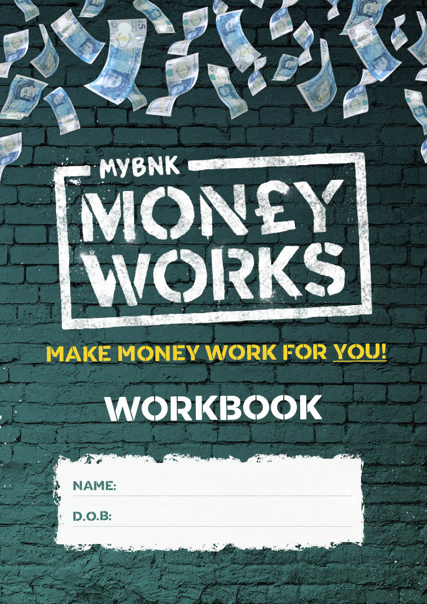

**Learning Outcome(s):** None

**Specific Page Notes**:

* Please ensure name and DOB is clear.
* Check DOB is not todays date.
* Ensure name here is the name they wish to be known by and that it matches the name on the next page.

# Page Breakdowns – Student Declaration

**Marking notes:** None

**Sample Answers:** Full legal name they wish to be on the certs.

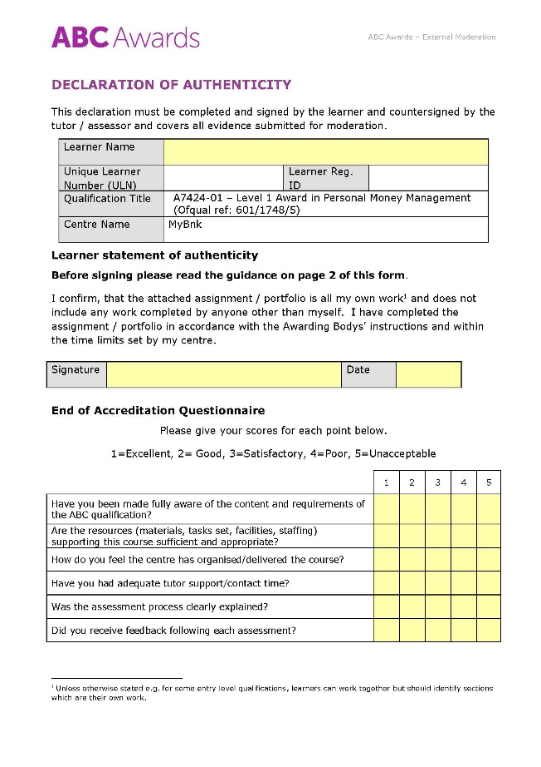

**Learning Outcome(s):** None

**Specific Page Notes**:

* Please make sure learner completes all boxex marked in yellow.
* Do remind learners the questionnaire has 1 as the best and 5 the worst response

# Page Breakdowns – Assessor Dec and Tutor Comments

**Marking notes:** None

**Sample Answers:** Full legal name they wish to be on the certs, ticks in the questionnaire

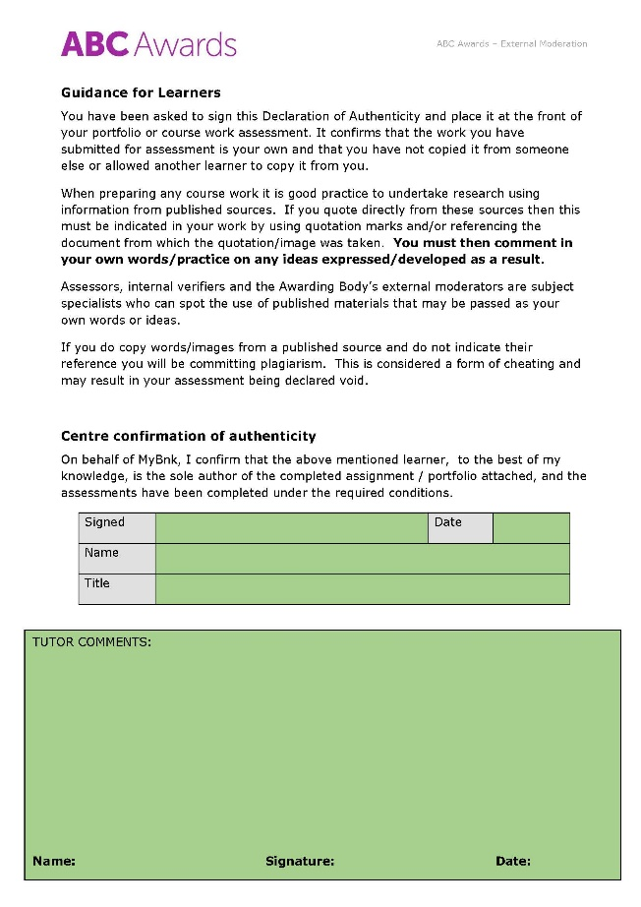

**Marking notes:** None

**Sample Answers:** See Tutor Comments page for more info on how to complete this

**Learning Outcome(s):** None

**Specific Page Notes**:

* You need to complete all green boxes on this page
* Separate notes ate given on completing the tutor comments box after the page breakdowns

# Page Breakdowns – My Money Promises

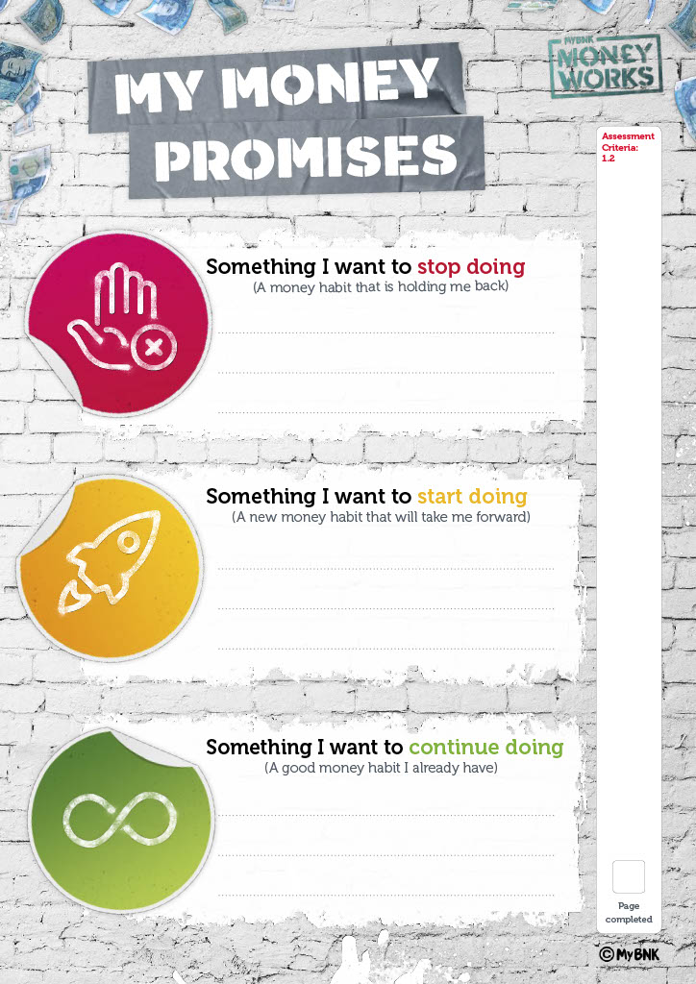

**Learning Outcome(s): 1**.2 – “Set personal goals and identify steps they can take to improve their financial situation”

**Specific Page Notes:**

* Each box will need to have an answer in it – “nothing” is not an acceptable answer.
* Any habit that is financially linked and meets the criteria in each box is acceptable. (i.e the ‘Stop Doing’ box should be a negative habit, the other two are positive)

**Marking notes:** This page is in support of the Money Goals page – these answers should be financial related. Basic answers such as “saving”, “spending less on stuff” and “think before I spend” are fine, but should be commented on to see if the learner can expand to more fully prove their understanding.

**Sample Answers:**

“I want to start saving”

“Buy less takeaway”

“Start checking my bank account regularly”

“Stop wasting money on things I don’t need”

“I’m going to start checking if I can get cheaper bills every year”

# Page Breakdowns – My Money Goals

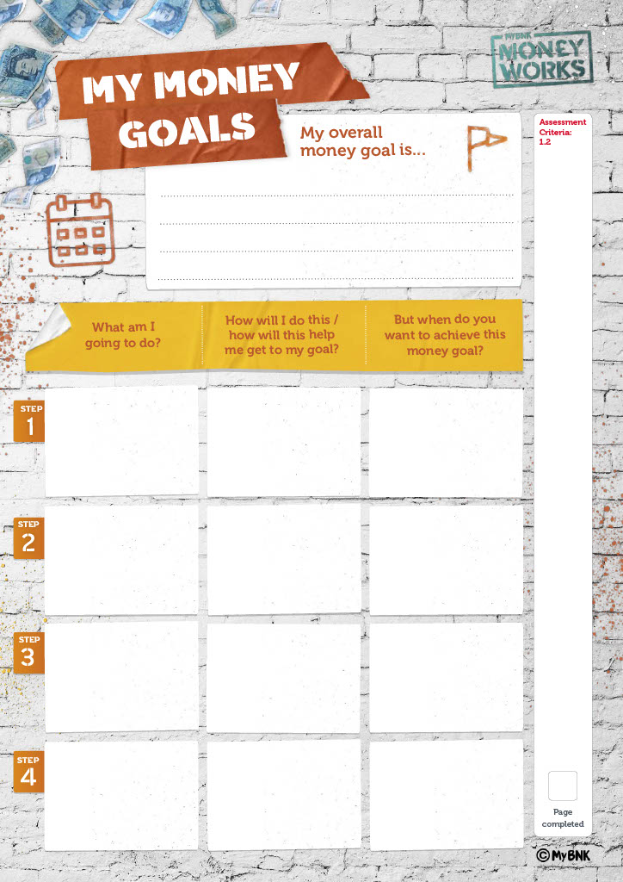

**Marking notes:** This page is in support of the Money Goals page – these answers should be financial related. There should be clear link between the actions picked in the bottom boxes to how that will aid them in getting to their goal. Time frames can be specific (3rd May) or more general (1 month) but should always be included. Steps should be in a logical, chronological order starting with step 1. Learners should be encouraged expand on 1 word answers.

**Sample Answers:**

**Goals**: “Save enough for a Holiday”, “Buy a house”, “Start a business” “Have enough to start driving”

**Steps**: “Open savings accounts / to allow me to hold my savings and make interest / next week”

“Research / check how much I’ll need to save by comparing prices from websites / 5th June” etc

**Learning Outcome(s): 1**.2 – “Set personal goals and identify steps they can take to improve their financial situation”

**Specific Page Notes:**

* Each box will need to have an answer in it – “nothing” is not an acceptable answer.
* The goal should be in line with improving their financial situation but answers like holidays and driving are acceptable – the goal is to have enough money to do those things.
* Use of SMART targets will help learners fill this in correctly.

# Page Breakdowns – My Current Budget Income

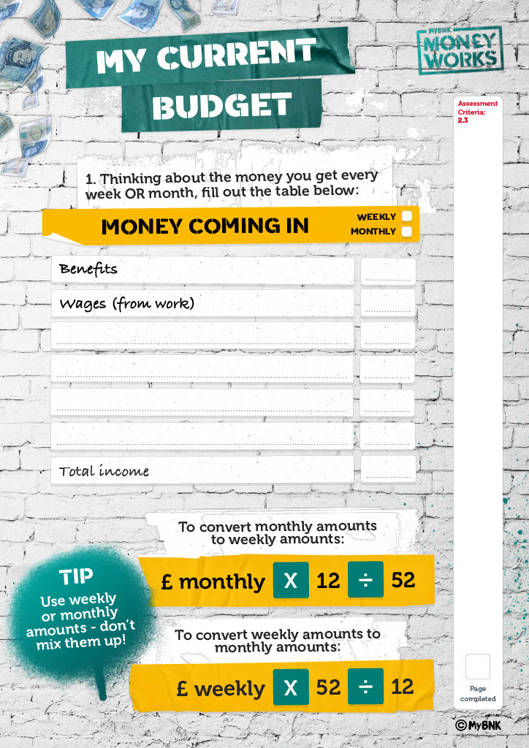

**Learning Outcome(s):** 2.3 – “ Prepare a personal budget prioritising spending in line with their wants and needs”

**Specific Page Notes:**

* Please ensure all totals are correct. Sense check any figures that seem unlikely and feedback to learner – “is this meant to be weekly?” “that seems high, is this correct”.
* Budgets MUST be marked to show weekly or monthly on both pages.
* On page 1, don’t forget to total the income to the bottom row.

**Marking notes:** You should check the math is being done correctly for totals. Feedback should reflect if there is an error in the math or possible issue with the figure entered. Trainer should not correct the figures themselves and should direct the learner to do so. Basic commenting – good work, thanks for sharing etc – is acceptable here

**Sample Answers:**

Any income is valid and should be included – pocket money, grants, side incomes etc

# Page Breakdowns – My Current Budget Outgoings

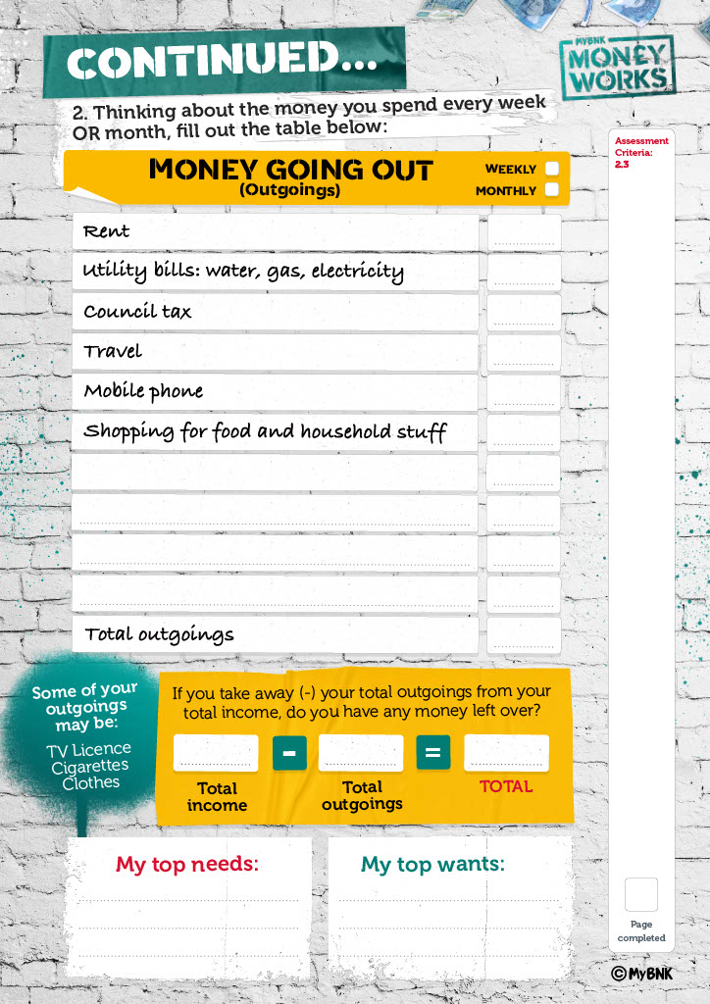

**Marking notes:** You should check the math is being done correctly for totals. Feedback should reflect if there is an error in the math or possible issue with the figure entered. Trainer should not correct the figures themselves and should direct the learner to do so. Comments on surplus or deficit amounts should direct learners to think about using or fixing “Where could you save that? What can you do to make the gap smaller”

**Sample Answers:**

Any outgoing is valid and should be included – think about other lines such as going out, shopping for clothes etc as other potential outgoings, especially if there is a large surplus left over.

**Learning Outcome(s):** 2.3 – “ Prepare a personal budget prioritising spending in line with their wants and needs”

**Specific Page Notes:**

* Please ensure all totals are correct. Sense check any figures that seem unlikely and feedback to learner – “is this meant to be weekly?” “that seems high, is this correct”.
* Budgets MUST be marked to show weekly or monthly on both pages.
* On page 2, don’t forget to total the income to the bottom row.
* Also – learner must provide the final sums needed to get a total.
* Don’t forget the needs and wants – we need 3 in each box.

# Page Breakdowns – Living Independently Costs

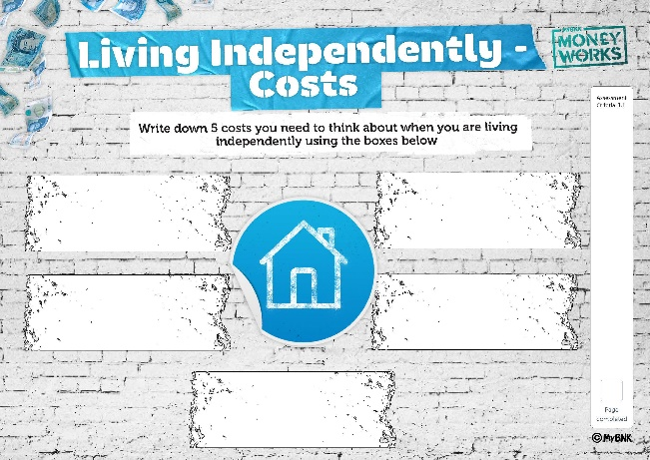

**Learning Outcome(s): 1**.1 – “Identify costs associated with Living Independently”

**Specific Page Notes:**

* This page, was previously names Household Costs, but was actually asking for costs to do with living independently.
* We have amended the new workbook to reflect this and will only require 5 answers from learners.

**Marking notes:** Simple list marking is ok here – “good list, thanks” or “well remembered” type of comment is ok with this page

**Sample Answers:** Gas, Elec, Water, Rent, Council Tax, Phone, TV Licence, Contents Insurance, Entertainment package, Broadband, Food, Toiletries, Travel costs, Car costs, Childcare etc

# Page Breakdowns – Sources of income

**Learning Outcome(s):** 2.1 – “Identify different sources of income”

**Specific Page Notes:**

* Each box will need to have an answer in it – “nothing” is not an acceptable answer.
* Answers here should all be suitably different from one another - Full Time Job and Zero Hours would be considered to be too similar.

**Marking notes:** Learners should ensure they put an answer in every box - books will require 5 answers. If learners are capable, they can be asked to give a brief explanation as an extension but one word answers are ok here. A “good list, well done” response is also acceptable

**Sample Answers:**

Job, Benefits, Pension, Grant or Bursary, Investments, Interest on savings, Self Employment, Student Loan, Selling old stuff of ebay, Surveys or Focus Groups, Renting items out (FatLlama) etc

Do NOT accept gambling, anything that requires borrowing (except student loan as it may be a sole income source) or anything illegal as answers.

# Page Breakdowns – Wage Slip Deductions

**Learning Outcome(s):** 2.2 – “Identify deductions from a payslip”

**Specific Page Notes:**

* This page requires 2 answers from a possible of 4.
* Deductions should be explained. Basic is fine here.

**Marking notes:** Basic answers such as “Tax – public services” are barely acceptable. Learners should be prompted to answer in full sentences where possible and to give at least a sentence of description. “Tax is money taken for public services”

Please ensure both are different, and reference the correct deductions

**Sample Answers:**

Pensions – Should mention retirement, money saved for older years etc

Tax – Should make reference to public spending, gov use etc

Student Loan – repayment of student loans to SLC

NI – National Insurance – should reference state pension entitlement, other benefit entitlement (JSA for example)

# Page Breakdowns – Banking

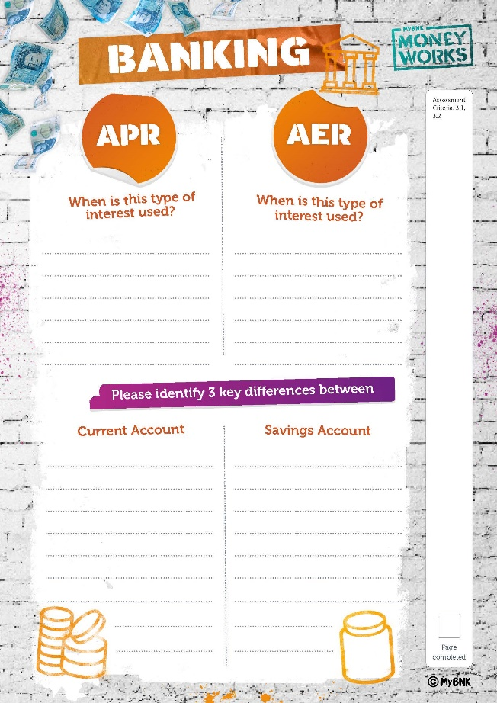

**Learning Outcome(s):**

3.1 – Identify key differences between a current and savings account

3.2 – “Identify the difference between interest on savings and interest on borrowing"

**Specific Page Notes:**

* Note that this page has 2 attached Learning Outcomes. If you are using witness statements to evidence this page, be aware it counts as 2 assessment points – which is now the new maximum per learner.

**Marking notes:** APR / AER boxes do NOT need the acronym meaning but is it’s a good idea. The minimum answer is to identify what that interest is used for – savings or borrowing

**Sample Answers:**

For APR: The cost of borrowing money / The extra they add when you take a loan / A percentage they charge you for using their credit services etc

For AER: The reward for saving you money / The money banks pay to get you to save with them / A payment made based on how much money you have in a savings account.

For differences between accounts, between 3-5 is acceptable but must be presented as differences

For example – Overdraft / No Overdraft is acceptable. Lower Interest Rate Vs Higher Interest Rate. Automatic payment available / No auto pay available etc.

# Page Breakdowns – Ways to Pay

**Learning Outcome(s):** 3.3 – “Define different forms of payment methods identifying when they might be used.”

**Specific Page Notes:**

* This page has being reworked to only ask for 4 examples and to make the expectation of the 3 elements being asked for clearer by adding tags to each box.

**Marking notes:** Note the 3 elements being asked for by the learning outcome – The form of payment, a definition of that form of payment and where that form of payment can be used. Missing one of the 3 elements will mean the example is incomplete. Learners can use to use full sentences if they wish: “Cash, which is paper money or metal coins, can be used in markets”

**Sample Answers:**

* Cash, Paper money or coins, spend in the markets
* Direct Debit, Automatic payments that can change every month, Pay my phone bill
* Contactless, pay by tapping your card, pay for bus in London
* Standing order, automatically pay someone the same amount every time, pays for rent
* Cheques are bank made slips of paper you can send in the post to allow someone to get cash on the other end from you safely

# Page Breakdowns – Borrowing and Debt (p1)

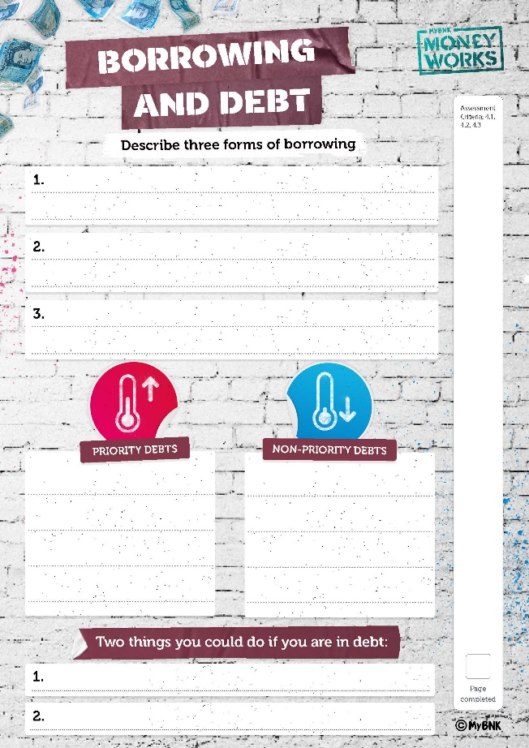

**Learning Outcome(s):**

4.1 - “Describe 3 forms of borrowing”

4.2 – “Differentiate between priority and non-priority debts”

4.3 – “State two actions that can be taken if in debt”

**Specific Page Notes:**

* This page contains 3 learning outcomes. If this page is empty when submitted, a witness statement is no longer enough to cover all 3 points and the book will fail
* Note the term DESCRIBE in the top exercise – learners need to add a description of the form of borrowing they are discussing. These should be ways to borrow – not companies who can borrow to you (Bank is not acceptable, but bank loan with description is)

**Marking notes:**

Top section – ask for as much detail as learner can give, but a form of borrowing with description is valid. Loan sharks are an acceptable answer as long as the description mentions illegality.

Priority Debts – Ensure the debts are in the correct lists – remember that only debts that lead to disconnection, court or jail or eviction count as priority debts – phone bills are technically priority debts, water is a non priority as they don’t disconnect. HP Loans are only considered a priority debt if the item is essential for income – a van for a self employed plumber for example.

For bottom boxes – encourage expansion. “Call a debt charity” is acceptable, but you should see if the learner could provide a named charity, for example.

# Page Breakdowns – Borrowing and Debt (p2)

**Sample Answers:**

***Describe 3 forms of borrowing:***

“Mortgage: A loan to buy a house”

“Business Loan: A loan from a bank to start my own company”

“Credit Card – A card a bank gives you with a credit limit you can spend and pay back later”

“Student Loan – A loan to help you pay university costs which you pay back when you start working.”

***Priority and Non Priority Debts:***

PRIORITY DEBTS: Rent, Gas, Electric, Court fines, TV Licence, Phone bill

NON PRIORITY: Friends, Water, Credit Card, Overdraft, Loan Shark, Store Card

***Two things you could do if you are in debt:***

“Call someone and ask for help”

“Talk to the people you owe money to and see if you can arrange a plan”

“Don’t panic”

“Stay calm and make a plan”

“Do a budget”

**(For both Priority/Non Priority and Two things you can do, answers are provided on the “Dealing with Debt” handout”**

# Page Breakdowns – Witness Statements

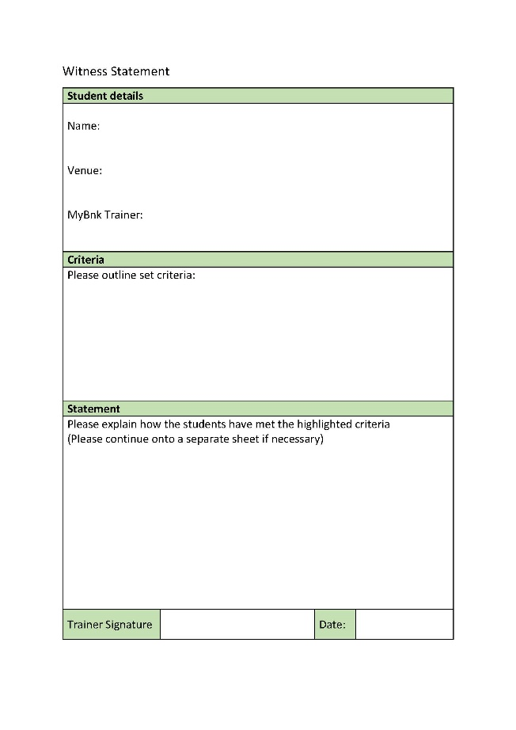

**Learning Outcome(s):** None

**Specific Page Notes:**

* Please ensure witness statements are only used in exceptional circumstances
* You should only use these to evidence a maximum of 2 learning objectives
* Please state the entire learning objective in the “Criteria” box
* Statement should include how the learning objective was reached, including method used and, if possible, what was said. I can be helpful to say that you are satisfied that the learner understand based on your interaction

**Marking notes:** Detail is important, please ensure you give detailed statements when needed. You should refer to:

1. What was done
2. What did the learner do in response
3. Does this alone meet criteria or is it to supplement what’s in the book?

**Sample Statement:**

“Learner was asked to name household costs verbally by assessor.

With some gently prompting, learner managed to give a list of 10 costs as required by the learning objective. This discussion with the page submitted prove he has met the learning outcome”

# Page Breakdowns – Marking Page

**Learning Outcome(s):** None

**Specific Page Notes:**

* Make sure the learner name is in the top box as they have it spelt in their workbook
* Please put a date next to EACH LINE in the Learning Objectives – do not use one date entry for the whole box.
* If there is any extra evidence, or a witness statement being used for that learning outcome, please note it in the comments box

**Marking notes:**

The date entered should reflect when the learner completed the outcome to your satisfaction – which might mean you have different dates for different people. Likewise, if they all finish the book on the last session, the dates will stay the same

**Sample Answers:** The date of completion per learning outcome. If there are witness statements or evidence, note this in the comments box:

“Witness statement supplied”

“Additional evidence attached – (include name of file or description of evidence)”

# Tutor Comments Box – Final Comments:

The tutor comments box is for the assessor to provide feedback to the learner and should contain the following elements:

1. Feedback on what they did well on course and in portfolio
2. How did they meet the assessment criteria for the course
3. Have they passed or failed?

A quick way to make these comments is to answer each question in turn to form the statement. For example, you can pick 1 from each of the sections below, put them together and you have a fully formed tutor comment

1. **Feedback on learning (be specific to the learner, these are just samples of feedback)**

* “You did a great job at explaining the ideas to your peers when needed. You also showed a great understanding of the banking systems in the UK as proved by the banking page in the book!”
* “Well done for keeping up with the workbook even when it was difficult. You worked really hard to keep up and asked good questions when you weren’t sure”
* “A solid effort this week – you answered questions well and even tried some things you didn’t want to do at first. Well done for trying things outside of your comfort zone and great work on getting the book finished!”

1. **Met the Criteria? (Pick one from below** **or your own equivalent)**

* Learner has demonstrated their understanding via the portfolio submitted and through discussions in the training room.
* Learner has successfully completed their portfolio, therefore proving their understanding of the learning point of the course
* This portfolio is completed to the required standard to prove their understanding of the course outcomes
* *(If using witness statements)* Learner also has a witness statement written up in support of the evidence in this portfolio
* *(If using additional evidence not in portfolio) In* addition to the portfolio, learner has submitted [type of evidence here] as proof of meeting the learning outcome.

1. **Pass or fail? (Pick one from below or your own equivalent)**

* Assessor recommends pass
* Assessment – book passes
* The workbook passes the requirements of the course
* This book passes

**For example, if you were writing a comment for someone with a witness statement, it could look like this:**

*“You did a great job at explaining the ideas to your peers when needed. You also showed a great understanding of the banking systems in the UK as proved by the banking page in the book!*

*Learner has demonstrated their understanding via the portfolio submitted and through discussions in the training room. Learner also has a witness statement written up in support of the evidence in this portfolio. Assessment – book passes”*

# New Salesforce Interval Verification System – Guidance Notes:

We have now completed work on our IV alert system! Please follow the guide below and contact nick@mybnk.org if you have any questions.

As part of the recommendations from ABC, we have built a new system to allow trainers to see the feedback from the IV team more easily and to keep a central record of work to be carried out. **From now on, IV’s will use salesforce to indicate whether your course is passable or not.** They will pick a sample of learner portfolios and assess your marking and completion of the relevant paperwork. If the sample is unsatisfactory, it will halt the entire group from being processed unless it is resolved.

IF ALL IS OK:

* The IV will record this on salesforce and the tutor will receive confirmation that all is ok with course.

IF THERE IS AN ISSUE:

* The IV will record this on salesforce. An email will be sent to you to alert you to the fact that an IV had provided feedback. You will need to follow the link given to the record to view the moderation reports and resolve the issues.
* You will need to tick the box labelled “IV PROCESS – Trainer Comments Acknowledge” to show you have seen the comments
* Once you have resolved the issues, you must go back to the record and tick “IV PROCESS – Comments Actioned”
* The IV will be alerted to check the new evidence and confirm whether it passes. If they are happy, you will receive an email saying your course has passed. If there are further issues, the course may be passed on to the Head of Education for review.